28th May 2018

**YOKOHAMA Supplying OE Tyres for ŠKODA KODIAQ production in Nizhny Novgorod, Russia**

YOKOHAMA announced today that from April 2018 it has been supplying its BluEarth-A AE-50 tyres to Volkswagen AG subsidiary ŠKODA for use as original equipment (OE) on the automaker's Kodiaq. The BluEarth-A AE-50 tyres are being supplied in two sizes, 235/55R18 100V and 215/65R17 99V, for Kodiaqs to be sold in Russia. The Kodiaq is the second ŠKODA vehicle to come equipped with BluEarth-A AE-50 tyres; ŠKODA OCTAVIA has come equipped with either 205/55R16 91V or 195/65R15 91H size BluEarth-A AE-50 tyres since November 2016. Kodiaq’s to be sold in Russia are being made by Volkswagen Group Rus.   
  
Developed under the “YOKOHAMA Pursuit of Driving Pleasure” concept, “BluEarth-A AE-50” tyres are fuel-efficient tyres featuring excellent wet grip and other functionalities that deliver superb driving performance and comfort in a wide range of road conditions. The BluEarth-A AE-50 tyres are highly regarded by Volkswagen AG, as evidenced by Volkswagen Group Rus’s use of the tyres on its Tiguan and Jetta as well as the Kodiaq and Octavia.   
  
The BluEarth-A AE-50 tyres for all four vehicles are being manufactured at YOKOHAMA’s Russian tyre manufacturing and sales subsidiary, LLC Yokohama R.P.Z. The subsidiary was established in December 2008 and began production near the end of 2011, making YOKOHAMA the first Japanese tyre maker to manufacture passenger car tyres locally in Russia. The Russian subsidiary has since increased its plant’s capacity to 1.6 million tyres a year, a 2.3-fold increase from the plant’s capacity at the start of operations in 2012.

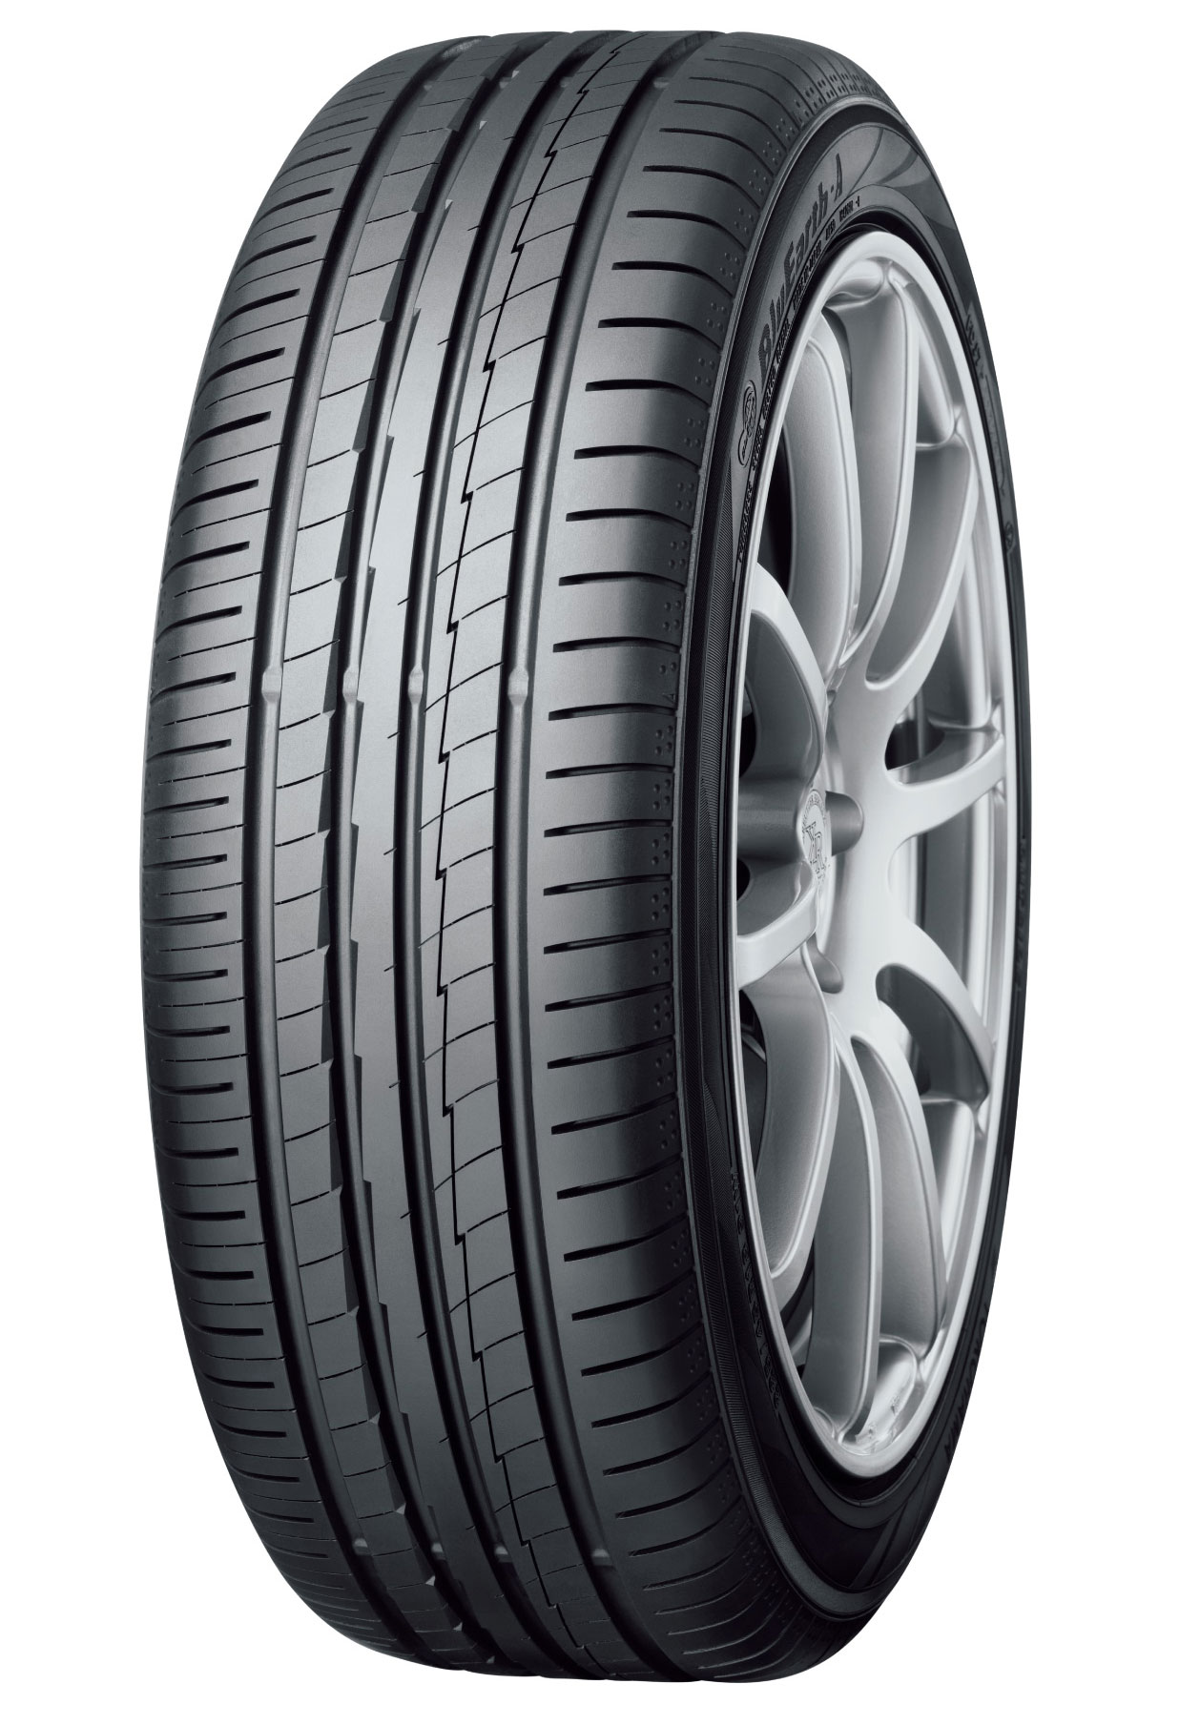

*The BluEarth-A AE-50; tyre shown in photo differs in size from those installed on the Kodiaq (wheel shown in the photo is not standard equipment)*